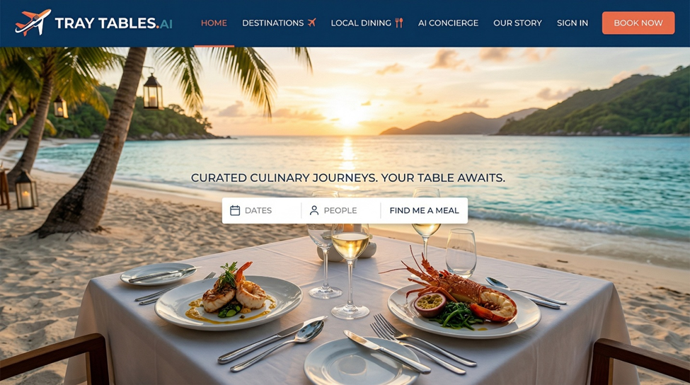
PRD: Regional Food Discovery & Travel Dining App
TL;DR
An AI-powered travel dining app that helps travelers discover hyper-local, regionally authentic dishes and restaurants. It combats generic tourist dining by surfacing canonical regional dishes, building personalized meal plans, and supporting the full journey from pre-trip planning to post-dining sharing and community contribution. Target users: first-time and repeat travelers, solo and group/couple travelers, those planning ahead and making same-day decisions.

GOALS
Business Goals
- Build proprietary regional food intelligence as a competitive moat
- Differentiate from generic map/review platforms (Google, Yelp) through food-forward features and trust scoring
- Create reusable trust/performance scoring models for restaurants and dishes
- Increase repeat usage across trips
- Foster community via post-dining contributions and achievements
User Goals
- Find dishes unique to the area being traveled in
- Find restaurants that showcase canonical regional dishes, complete with dish metadata (what it is, ingredients, brief history, how that history connects to the region)
- Find restaurants by neighborhood/area on specific travel days
- Plan breakfast, lunch, dinner, snacks, and street food for up to 14 days of travel
- Optimize a dining route based on neighborhoods and selected restaurants
- Record and share dining experiences
Non-Goals
- This is not a general-purpose restaurant review platform like Yelp or Google Maps
- Not a hotel or full travel itinerary planner
- Not a food delivery or ordering app

USER STORIES
Personas & Sample Stories
First-Time Traveler
- As a first-time traveler, I want to set up my destination, trip dates, and basic preferences so I can receive tailored dish and restaurant recommendations before my trip.
- As a first-timer, I want a short list of “must-eat” regional dishes to prioritize authentic experiences.
Repeat Traveler
- As a repeat visitor, I want the app to recommend off-the-beaten-path dishes and places, so I don’t repeat my first-trip experiences.
- As a repeat traveler, I want to record and compare different meals across my visits.
Solo Traveler
- As a solo traveler, I want to filter for safe, welcoming, or lively venues with solo-seating so I dine confidently anywhere.
Group/Couple Traveler
- As a group or couple, I want filters for group seating, family/child-friendly venues, or lively group atmospheres, to streamline our planning.
Food-Focused Traveler
- As a devoted foodie, I want to discover and log “best of” lists (e.g., best ramen, best pizza), and track personal dining achievements.
Dietary-Constrained Traveler
- As a gluten-free user, I want to see only venues and dishes likely to fit my needs, and be reminded to confirm directly due to AI limitations.
All Travelers
- As any user, I want to build a multi-day, multi-meal itinerary for my trip, lock or skip meal slots, and export or share my experiences with the traveling community.

FUNCTIONAL REQUIREMENTS
Trip Setup (P0)
- Input destination city(ies) (non-home)
- Input trip dates
- Select (or optionally skip) neighborhoods/areas per day
- Select meal types per day (breakfast, lunch, dinner, late night, street food), up to 14 days
Eater Profile / Food Preferences (P0)
- Eater-type multi-select: Veggie Lover, Adventurous Eater, Comfort Seeker, Local Purist (weights: local-language reviews, repeat visitors, locals’ feedback, longevity), Trendy Explorer (weights: tourist/influencer reviews), Street Food Lover, Fine Dining Enthusiast, Foodie Completist
- Dietary & Health Constraints (hard filters): Vegetarian/Vegan (strict/flexible), Gluten-Free, Dairy-Free, Nut Allergy, Shellfish Allergy, Halal, Kosher, Alcohol-Free (for drink pairings)
  - Persistent disclaimer: All results AI-generated; cannot guarantee health/safety; users must check directly with restaurants
- Set price range per meal
- Spice preference: High/Medium/Low
- First-time visitor vs. repeat visitor toggle (personalizes recommendations)
Must-Try Dish Recommendations (P0)
- Surface canonical regional dishes per city/region, derived from trusted resources
- For each dish: what it is, what’s in it, brief history, regional/cultural connection
- Distinguish must-eats for first-timers and hidden gems for repeats
Restaurant Recommendations (P0)
- Restaurants listed by day, meal, and neighborhood/location
- Key menu items—including must-try local dishes
- Narrative description
- Photos: 1 exterior, 1 key dish (web/social sourced)
- Tags: Great Views, Great Service, Lively Atmosphere, Outdoor Seating, Pet Friendly, Child Friendly, Tasting Menu, Large Portions, Romantic, Great Cocktails
- Cuisine Type (e.g., Italian, Japanese, Mexican, French, Thai, Indian, Mediterranean, Southern, Asian fusion, Seafood)
- Price range, spice rating, eater-type match
- Links: restaurant site/Google page, full menu, reservation (if offered)
- Trusted resources: Michelin Guide, Eater, Thrillist, The Infatuation, TheFork, local publications/guides, Google Maps, Wikipedia
- Wine/drink pairings (opt-in)
- Logistical info: hours, reservation needs, accessibility notes
Timing Intelligence (P1)
- Dining time intelligence: peak/off-peak, when locals eat, when dishes may run out, closed/siesta days
Accessibility Notes (P1)
- Info on lines/wait times, reservation needs, language barriers (pulled from Google/Reddit/source data)
Route Optimization (P1)
- Optimize daily meal routes by neighborhoods and selected restaurants
Itinerary Builder (P0)
- User reviews recommendations, locks in or rejects (with prompt for re-run), can cancel any slot
- Generates a final, printable, in-app savable itinerary with summary per restaurant and must-try dishes
Offline Access (P1)
- Save itineraries and maps for offline use
Post-Dining Recording & Community (P1)
- After dining, user logs: images, 1–5 rating, open-form notes, tags (service, views, etc.)
- “Make public” toggle for sharing with platform
- Export trips to docs
- Achievements:
  - Prestige/Quality (e.g., Michelin Hunter, Three Star Legend, Bib Gourmand Explorer)
  - Geographic (Global Diner, City Conqueror)
  - Volume/Consistency (First Bite, Foodie 25/50/100)
  - Culinary Adventure (Adventurous Eater, Regional Specialist)
  - Dietary/Preference (Plant Powered, Allergy Aware)
  - Experience/Occasion (Date Night Pro, Group Feast)
  - Contribution/Community (First Review, Guide Maker)
  - Meta/Elite Tiers (Rising Foodie, Elite Diner, World Class Palate)
- Achievements displayable on public user profile (opt-in)

USER EXPERIENCE
Entry Point
- User navigates to web app, creates profile, starts new trip.
Step-by-Step Journey
- Trip Setup: Enter destination cities, dates, neighborhoods (optional), select meal slots per day (breakfast, lunch, dinner, late night, street food), up to 14 days.
- Food Preferences: Multi-select eater types, apply dietary/health filters (hard), set price and spice, choose first-time or repeat visitor. App displays persistent health/dietary disclaimer if any filters applied.
- Must-Try Dishes: Canonical dishes for trip location surfaced, showing full metadata (description, ingredients, history, regional connection). Separates first-timer “must-eats” and repeat “hidden gems.”
- Restaurant Recommendations: Presented by day, meal, neighborhood. Restaurant card shows exterior/food photos, description, tags, cuisine type, matching eater profile, menu/reservation links, price, spice, hours/info.
- Itinerary Builder: User locks selections per slot, can reject with written reason (triggers re-run), skip/cancel any meal. Route optimization prompts for most efficient eating path.
- Reservation Step: Reservation links for supported venues integrated from TheFork/OpenTable/Google.
- Final Itinerary: Savable and printable; includes detailed restaurant/dish summaries. Available offline if enabled.
- Post-Dining Logging: User rates meals, uploads photos, writes open-form notes, tags experience. Can make public for platform sharing or export trip.
- Achievements/Profile: Earn badges for milestones (quality, volume, dietary, occasion, adventure), visible on public profile if user consents. Stats tracked: countries, cities, Michelin stars, cuisines, volume.
Advanced Features & Edge Cases
- Health/diet disclaimer is persistent when any filter is active.
- If no results in a neighborhood, widen search radius automatically.
- All visual elements designed for mobile, visual-first info (photos/tags/icons at a glance).
- Social/influencer content weighted for Trendy Explorer; local-language/repeat feedback for Local Purist.
- Offline mode indicator, day-by-day timeline view for itinerary, easy visual achievement display.

NARRATIVE
Sofia, a first-time visitor to Tokyo, launches the app after landing in Narita Airport. Eager to dine beyond the usual tourist fare, she sets up her trip: five days in Tokyo, with plans to explore Shinjuku and Asakusa. She configures her eater profile as a Local Purist, determined to try only authentic, hyper-local food—and checks gluten-free on dietary preferences. The app’s persistent disclaimer reminds her to always contact restaurants directly for health safety.
On the Must-Try Dishes screen, Sofia discovers regional specialties: perfectly grilled yakitori, delicate gluten-free soba, and Tokyo-style oden. Each dish comes with photos, explanations of local ingredients, and a short history of its role in Tokyo’s culinary scene. Filtering for gluten-free options, the app suggests a renowned yakitori spot and a soba shop in Asakusa, both praised by locals and featuring long operational histories.
Sofia builds a day-by-day itinerary, planning breakfast at a market stall, savory lunches, and a special dinner at a cozy izakaya she books through the app’s reservation link. Each evening, she logs her experiences—photos of her meals, thoughtful notes, and ratings. Her first dining experience unlocks the “First Bite” and “Local Legend” achievements. Impressed, Sofia makes her experience public on her profile and is already bookmarking Kyoto for her next culinary journey, knowing the app will help her eat like a true local.

SUCCESS METRICS
User-Centric
- % of users trying 2+ new regional dishes per trip
- In-app user confidence rating vs. Google/Yelp (NPS-style)
- Time spent planning trip in-app vs. traditional methods
- % completing post-dining logging
Business
- Repeat trip usage rate per user
- Month-over-month active user growth
- Reservation conversion rates
- Community content volume (reviews/photos uploaded/month)
Technical
- Recommendation load <2s
- 99.9% uptime
- Offline itinerary/maps reliability
- AI suggestion accuracy (user rejection/re-run <20%)
Tracking Plan
Event | Description
Trip created | New trip initiated
Food preferences saved | User completes food profile
Restaurant card viewed | Viewed a restaurant recommendation
Link clicked (menu, reservation) | Clicked to menu/reservation/external page
Itinerary slot locked in | User accepts a recommendation
Recommendation rejected | User rejects and re-runs a suggestion
Post-dining log submitted | User logs post-meal experience
Content made public | User shares meal log
Achievement unlocked | Badge earned
Offline itinerary downloaded | User downloads itinerary/map for offline

TECHNICAL CONSIDERATIONS
- AI/ML engine trained on regional dish/restaurant data, eater types, health filters
- Data aggregation pipeline: Michelin Guide, Eater, Thrillist, Infatuation, TheFork, local sources, Google Maps, Wikipedia
- Image sourcing (exterior/menu item photos) from web/social
- Offline-first storage for trip itineraries/maps
- Secure storage & encryption for user data and dietary constraints
- GDPR/CCPA compliance; explicit consent for public content and AI disclaimers
- Integration: Michelin API, Google Maps (location/data/etc.), TheFork/OpenTable, Instagram/TikTok (dish photos), Reddit (lines/language)
- Human-curation validation layer for high-accuracy dish/restaurant metadata
- Scalability: launch with top 50 global cities, cloud CDN for image load, high concurrency
Potential Challenges:
- Ensuring rapid updates for changing menus/hours/closures
- Social/API rate limits for influencer and image data sourcing
- AI hallucination risks—use human review for core canonical outputs

MILESTONES & SEQUENCING
Project Estimate: 4–8 weeks for MVP
Team Size: Medium (3–5) – 1 PM/Designer, 2 Full-Stack Engineers, 1 AI/Data Engineer, 1 part-time QA
Phase 1: Core MVP (Weeks 1–3)
- Trip setup, preference collection, must-try dish surfacing, restaurant recommendations, basic itinerary builder (seed data for 5 cities)
Phase 2: Enrichment & Reservations (Weeks 4–5)
- Route optimization, timing intelligence, reservation links, offline save, trusted source ingestion
Phase 3: Community & Achievements (Weeks 6–8)
- Post-dining journal, achievements system, public profile sharing, user-generated content, offline mode



